Create table and add primary key:

CREATE TABLE STRANGER(NAME VARCHAR(20),AGE int, PERSONID INT PRIMARY KEY,CITY CHAR(20));



Create order table:

CREATE TABLE ORDER(OrderID NUMBER(20) PRIMARY KEY, PERSONID NUMBER(11), DELIVERYCITY CHAR(10), DELIVERYDATE DATE);

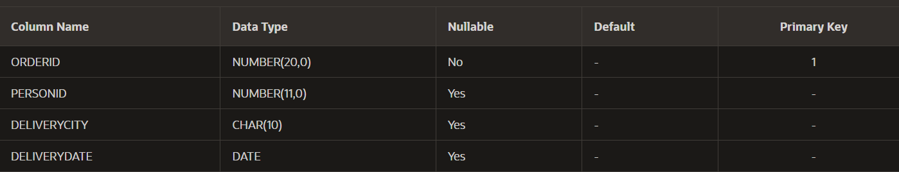

Adding foreign key:

ALTER TABLE ORDERDETAILS ADD FOREIGN KEY(PERSONID) REFERENCES STRANGER(PERSONID);